**Recruiter Manual – Using LikeMe & DSM to Optimize Recruitment**

**Abstract:**

This manual was made with the intent to guide you, the recruiter, through LikeMe & DSM+ usage, best practices, and how these applications will help you achieve more closures, cast a wider candidate net, and predict future demand with ease.

**LikeMe:**

LikeMe is an application that was created solely with the recruiter in mind. This app gives you the power to fine-tune your boolean searches like never before. LikeMe is made up of a strong foundation of previous hiring data – when building this application, we looked at thousands of job descriptions, past hires, and customer specific requirements in order to design a platform that will not only give you the ideal boolean search, it will also provide you with closely related skills that match the particular customer requirement based on a particular context.

LikeMe is built of two core components –  **skill radar and context based searches. Here’s how they will help refine your recruitment strategy:**

**Skill Radar:**

Skill Radar consists of 5 sections – all of these sections work in tandem in order to ensure that you will be able to make the ideal Boolean string for a particular requirement.

**Skills Section – how to use it:**

**In this section, you are able to select skills, skill bucket, customer, location, and how broad or narrow you would like your search to reach.**

1. Select the skill you would like to see the keywords for.
2. Select the Skill bucket which this skill belongs to (optional)
3. Select the specific customer you are recruiting for (optional)
4. Chose how broadly you would like this search to reach using the slider.
5. After all of this is entered, you will be given a view of the **Skill Radar, a spider plot with the skills distributed anti-clockwise, based on the similarity with the skill selected.**

**Skill Radar**

**This spider plot gives a crystal clear view of which skills are closely related – this helps broaden your scope of which key words you can put in a Boolean string to help you find candidates.**

1. The skill radar spider plot is based on the output you put in the skills section – web will be as narrow or wide depending on the number of skills you select to be searched.

**Boolean Strings:**

This section will give you an ideal Boolean string to use in your searches. This string has a variety of key words that you can chose from in order to refine your search.

**Customer Radar:**

Here you’ll see how many people a particular customer has hired for any particular skill.

**Search Wikipedia:**

Working on a requirement with a brand new set of skills? Don’t worry – LikeMe has a built in feature that will lead you to webpages so you can expand your knowledge.

**How does this all help?**

The skill radar section of LikeMe works together to make sure that you are well informed about what skills to look for in a resume, use in a Boolean search, and what customers have hired for in the past.

Not only does help you find an ideal candidate, it will also sharpen your knowledge and make you an even better recruiter.

**\*Insert screenshots with real requirements as an example\***

**Context Based Search**

With LikeMe’s context based search feature, you have the ability to search for both internal & external candidates based on the project specific criteria, skill sets, and qualifications.

This type of search will give you:

* Resumes of candidates within & outside of HCL
* Candidates that are relevant to the skills and context you have submitted.

**How it works:**

1.Select whether you want to search for candidates **inside of HCL** or **outside of HCL**

1. Manually enter the skills that this candidate needs to have

OR

1. Select the skill which is mandatory for the project, the application will select related skills to perform the search. .
2. Enter the context – the context is simply the job description. Copy & paste this and in turn you will receive relevant candidates that are relevant to your search criteria.

**Why Use the Context Based Search Feature?**

**\*\*Add this\*\***

**\*Insert screenshots with real requirements as an example\***

**DSM +**

Demand Segmentation+ will give you a way to forecast demand for a particular customer. This application helps futureproof fulfillment %, projected revenue, and give a well-rounded view of skills per customer based on location.

**Demand Dashboard:**

**In order to predict demand, simply select –**

1. Region (USA or India)
2. Skill Bucket.
3. Quarter (For analytics only)

**Gives a view of:**

* Overall demand
* Fulfillment Percentage
* Drop Percentage
* Unfulfilled Overdue Percentage
* Forecast
* Revenue
* Top customers for selected skills
* Location based Demand
* Fulfillment % based on Location
* Fulfillment % based on Customer

**Why Forecast Demand?**

Forecasting demand will greatly help to increase the fulfillment percentage, devise plans for hiring, and optimize Cost to Company (CTC).

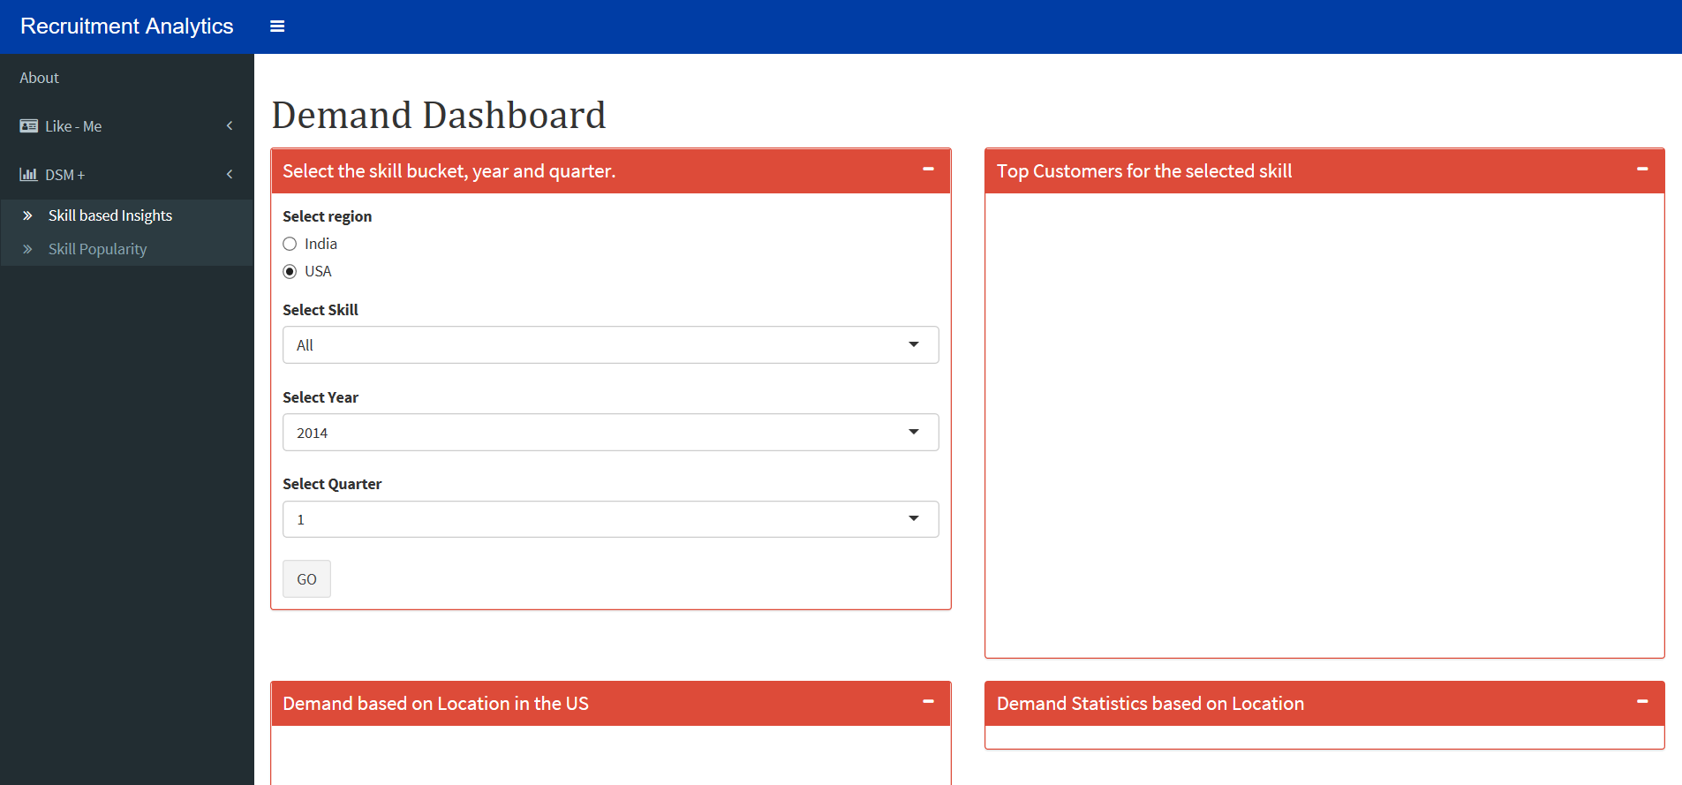

1. Open the Skill based insights page under the DSM+ tab.

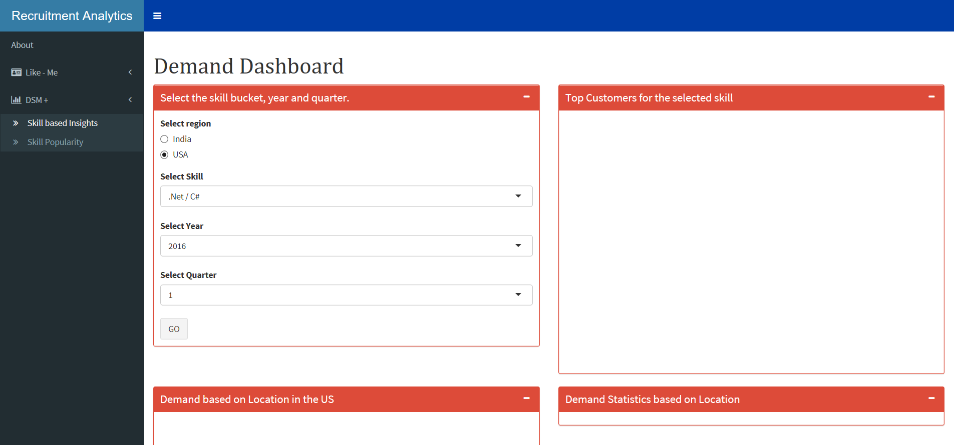

2. Select the Skill

**\*Insert screenshots with real requirements as an example\***